Bandit Level 2
DG Interns Hub | Week 1 | OverTheWire Bandit Writeup

Objective
Read a file whose name is a single hyphen.

Activity summary
Suggested learning command / approach: cat ./-. Use only on the authorized OverTheWire training environment.

Key learning
Handling filenames that look like command options.

Evidence
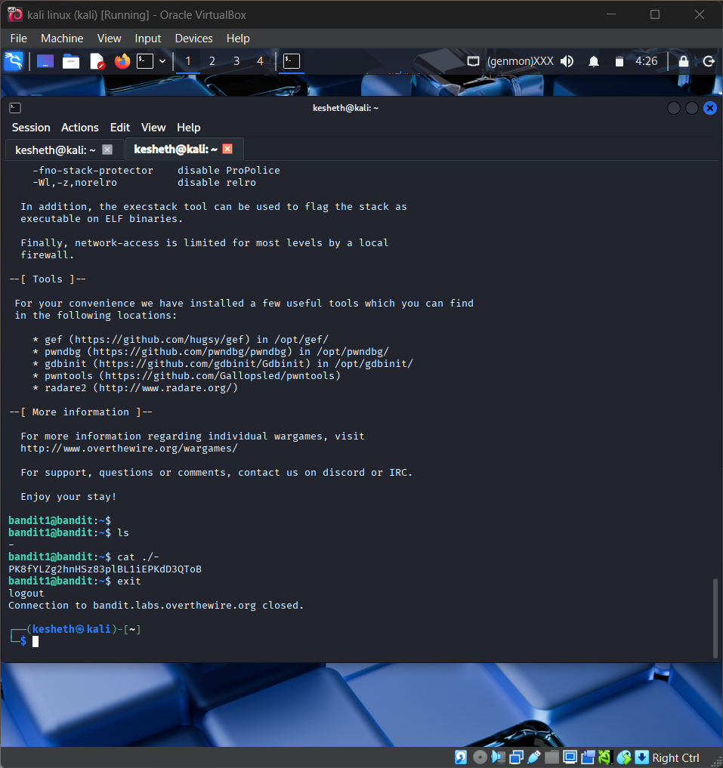
Screenshot: bandit_level_2.png
The screenshot is evidence of level activity/login; it may not show every solution step. No passwords are reproduced.

